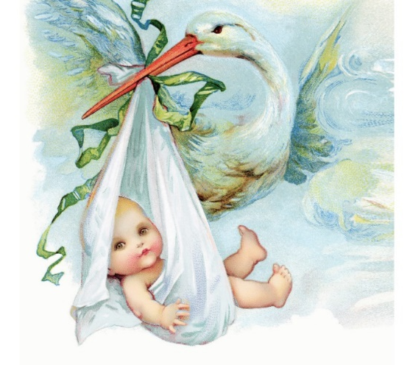

Stork’s, siblings, and Sharing: spending special time together

The majority of children around the world have at least one sibling. The sibling relationship is likely to last longer than any other relationship in one’s lifetime and plays an integral part in the lives of families.

In early childhood, four major characteristics of sibling relations are prominent (Howe N, Ross H, Recchia H. Sibling relations in early childhood. In Hart C, Smith PK, eds. Wiley-Blackwell Handbook of Childhood Social Development)

- Sibling interactions are emotionally charged relationships defined by strong, uninhibited emotions of a positive, negative and sometimes ambivalent quality. (Dunn J. Young children's close relationships: Beyond attachment. Thousand Oaks, Calif: Sage Publications; 1993.)

- Sibling relations are defined by intimacy: as youngsters spend large amounts of time playing together, they know each other very well. This long history and intimate knowledge translates into opportunities for providing emotional and instrumental support for one another, engaging in pretend play, for conflict, and for understanding others’ points of view.

- Sibling relations are characterised by large individual differences in the quality of children’s relations with one another.

- The age difference between siblings often makes the issues of power and control as well as rivalry and jealousy sources of contention for children, but also provide a context for more positive types of complementary exchanges, such as teaching, helping, and caregiving interactions.(Kolak AM, Volling BL. Sibling jealousy in early childhood: Longitudinal links to sibling relationship quality. Infant and Child Development 2011)

These characteristics of sibling relationship should be nurtured and supported as these experiences are a natural laboratory for young children to learn about their world. We can provide a safe and secure place for them to learn how to interact with others who are interesting and engaging playmates, to learn how to manage disagreements, and to learn how to regulate both positive and negative emotions in socially acceptable ways.

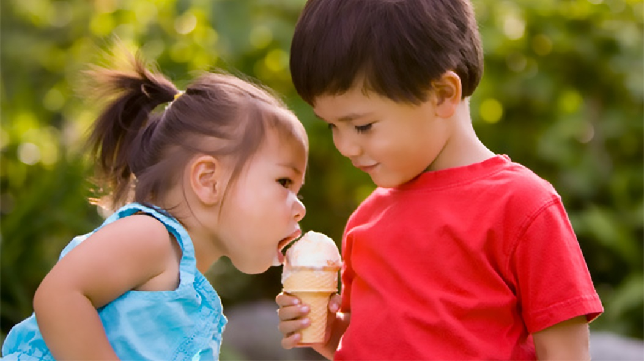

As a setting we encourage and value the importance of sibling play, nurturing home and family relationships whilst they attend Loughborough Campus Nursery, the positive benefits of establishing warm and positive sibling relationships may last a lifetime. Sibling relations provide an important context for the development of children’s understanding of their social, emotional, moral and cognitive worlds.

In particular, siblings play an important role in the development of children’s understanding of others’ minds, namely their understanding of emotions, thoughts, intentions and beliefs. Siblings seem to demonstrate an understanding of others’ minds and emotions during real-life interactions long before they show this understanding on more formal assessments. In particular, this understanding is revealed during episodes of teasing, pretend play, conflict resolution, teaching, and through their use of emotional and mental language during conversations. Young siblings who engage in frequent pretend play demonstrate a greater understanding of others’ emotions and thinking, show evidence of creativity in their play themes and object use, and are more likely to construct shared meanings in play. (Volling BL. Sibling relationships. In: Bornstein MH, Davidson L, Keyes CLM, Moore KA, eds. Well-being: Positive development across the life course.) (Kramer L. Learning emotional understanding and emotion regulation through sibling interaction. Early Education and Development 2014) (Hughes C, Fujisawa KK, Ensor R, Lecce S, Marfleet R. Cooperation and conversations about the mind: A study of individual differences in 2-year-olds and their siblings. British Journal of Developmental Psychology 2006)

This is what we’re going to do:

Spontaneous visits | Planned visit | Monthly activity
Key groups use their special time together to visit a child in attendance sibling in room – preferably outdoor play | Key persons liaise with each other for child to visit sibling room and spend quality time one-one ( can be left if within ratio) | Large group activity where children with siblings can come and participate in story time, musical movement, bubbles etc.
Deliver invitation for play sibling play dates … | Planned play session after invitation – use sibling sack for prompts if needed | Small groups to attend another rooms gathering time/singing time, tea time

Example invitation: The sibling could post the invitation or deliver it like a stork to their brother or sister
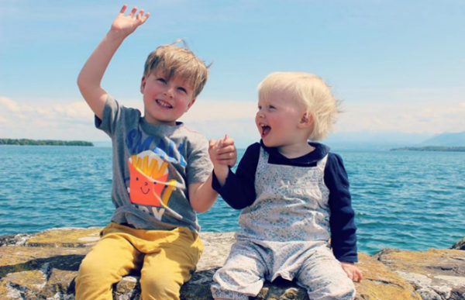
Esther and Seth
Can you come and Play? Explorers 17th Dec

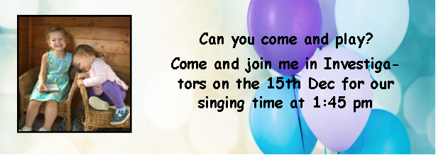

A Stork bag – sibling sacks are available for rooms to access as a focused activity if the early year’s educator wishes to provide a surprise element and teaching opportunity to build upon the four main characteristics of sibling relationships. This is not essential but an easy accessible resource if wanted. The practitioners will know their children and their interests so will be able to adapt and plan in the moment activities, follow the children’s lead or quietly observe the family and their play. These sacks if needed could include:
- Sensory items
- Book
- Bubbles
- Soft comfort toy – e.g. Stella the stork etc

