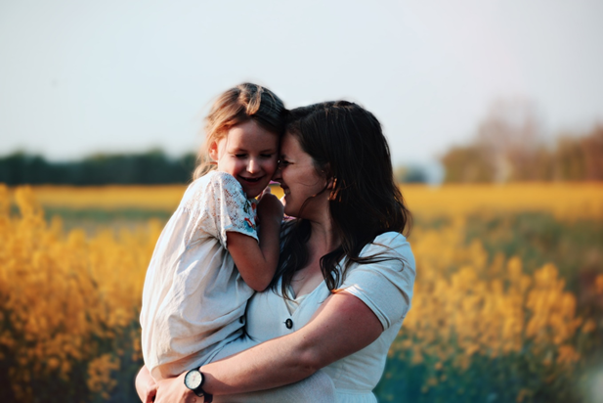



**Nurturing every child**

In order for any early year’s environment to be enabling, it is essential that all practitioners understand how children learn and the value of play and children’s independence. Another key principle is observation – observing each child you will not only learn what the children are learning but also how they learn as individuals.





*Personal, social and emotional development is the bedrock upon which the EYFS*

*Framework is built as well as being one of the seven areas covered by early*

*Learning goals.*

Every child is unique. They learn to be independent and strong through positive relationships. As practitioners we need to ensure we can provide those safe and stimulating environments and to be mindful that each child learns and develop in different ways and tr different rates.

Through our commitment as practitioners in providing outstanding practice to ensure children are perceived as special and well cared for; each have a deeply rooted sense of belonging where they are free to express their feeling; develop coping strategies and positive ideas about themselves and others, and to be acknowledged and affirmed.

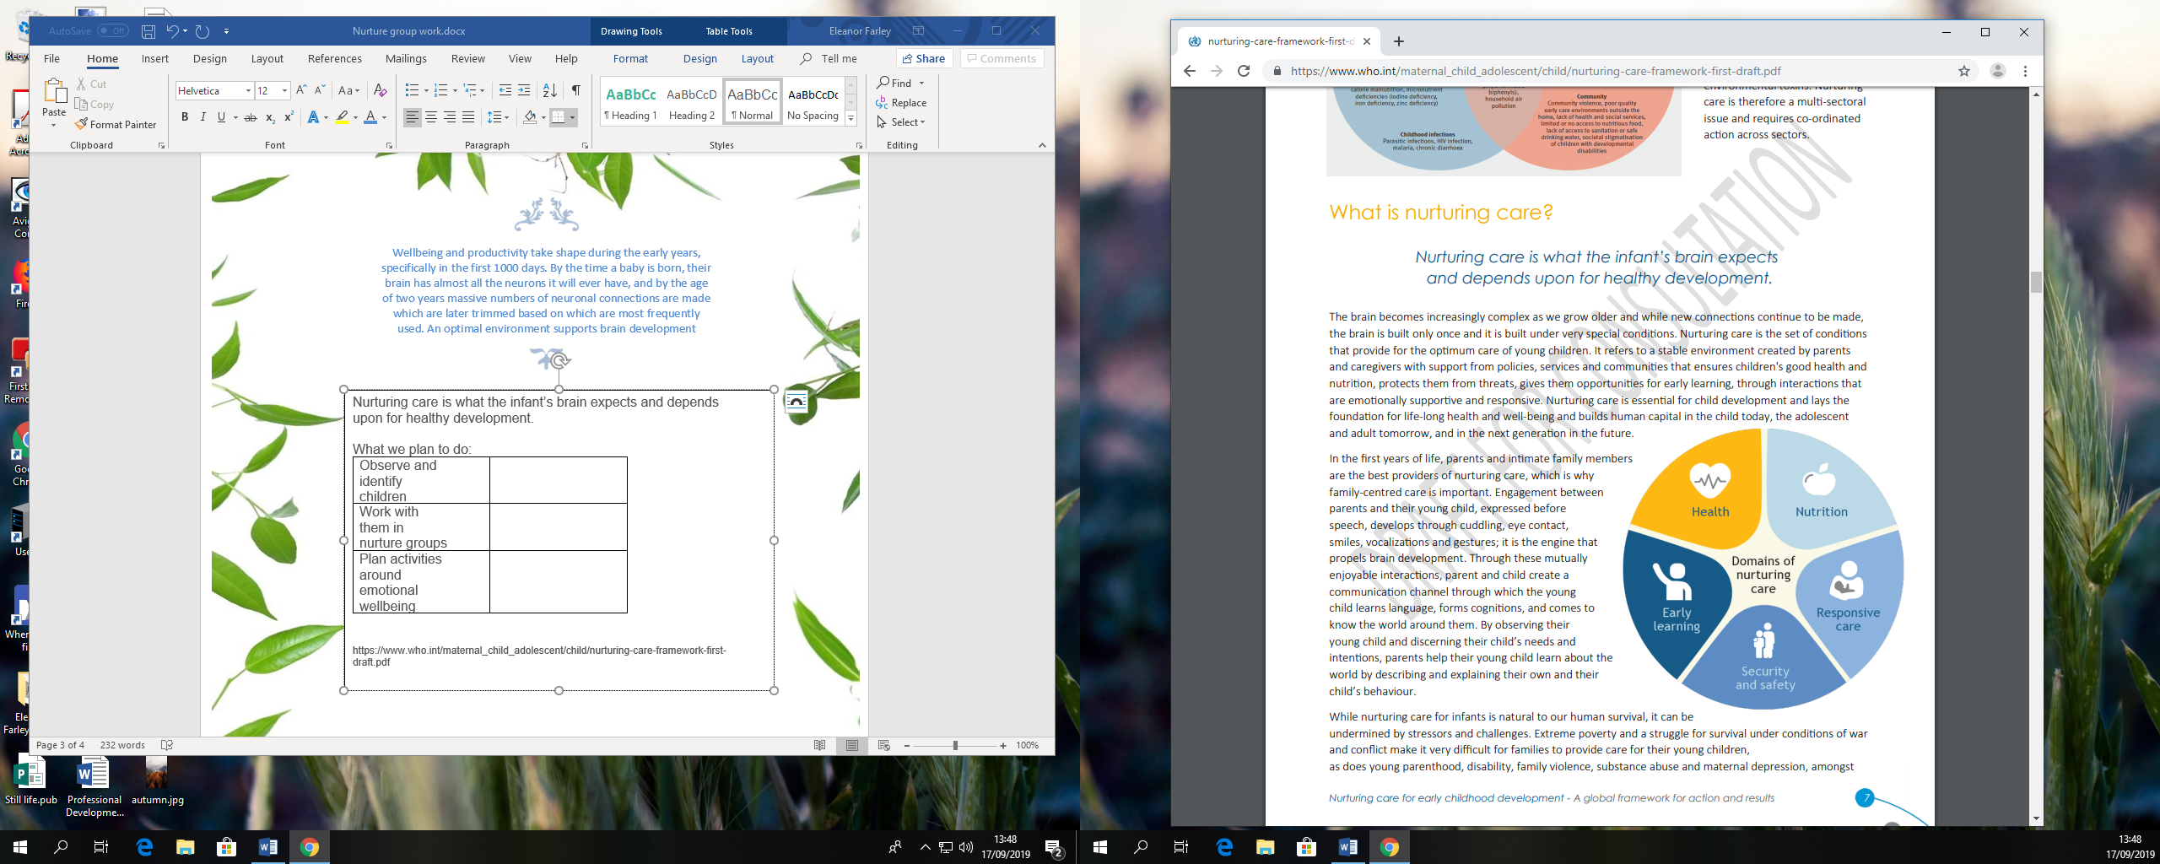

Nurturing care is what the infant’s brain expects and depends upon for healthy development.

What we plan to do:

|  |
| --- |
| Observe and identify children who could benefit from nurturing |
| Work with them in nurture groups to help build foundations of security |
| Plan activities around emotional wellbeing and interests of children |

Within the room there will be a wellbeing lead that will take ownership of the nurture group, this is to help identify and assess when the children need/ no longer need sessional work when building those secure attachments and confidence when transitioning into the room. A way to assess this and the children to recognise and manage their own feelings can be done through the child Leuven scales.

https://www.who.int/maternal_child_adolescent/child/nurturing-care-framework-first-draft.pdf

Wellbeing and productivity take shape during the early years, specifically in the first 1000 days. By the time a baby is born, their brain has almost all the neurons it will ever have, and by the age of two years massive numbers of neuronal connections are made which are later trimmed based on which are most frequently used. An optimal environment supports brain development.

Caregivers enable infants to participate in human communication and exchanges by playing their own part in the interaction as well as helping the infant engage. Caregivers/ practitioners must be sensitive to what their infant might be feeling or trying to do and be able to respond in ways that help their child achieve their emerging intentions. Sensitive caregivers observe their infants intensely, and notice changes in their child’s facial expressions, gestures, body movements and vocalisations. When caregivers match their actions and emotions to those of their young child, they impart significance to the infant’s acts, give them meaning, and reinforce the child’s feeling and actions and the role of these in the child’s development and relationships with others. Caregiver sensitivity and responsiveness is “built-in”, driven by intense love for one’s infant.



The fundamental theoretical model that underpins the effectiveness of nurture groups is John Bowlby’s (1965) attachment theory which argues that children acquire age-appropriate behavior through interactions with significant others.

Referencing to the EYFS Development Matters document as the bedrock of every child’s learning, we can pinpoint and refer to this for guidance if we feel a child could benefit from nurturing sessions.

The criteria for attendance of a nurture group will be based upon the child’s personal, social and emotional development within their age bracket and their ability/inability when:

* **Making relationships**
* **Self-confidence and self-awareness**
* **Managing feelings and behavior**

By spending time nurturing the little ones we will be:

Building affective bonds: Forming positive, trusting relationships with students and being responsive to their individual needs.

Modelling: Role modelling of appropriate behaviour/social skills between two adults participating in constructive interaction.

Cognitive restructuring: Perspective taking; Recognising triggers of anger; Distinguishing between helpful and unhelpful thoughts.

Affective education: Understanding, identifying and labelling emotions; Recognising physical and environmental cues of emotions; Providing opportunities for pupils to verbalise their emotional experiences.

Relaxation techniques: Mindfulness; Controlled breathing techniques.

**Criteria for Nurture Group**

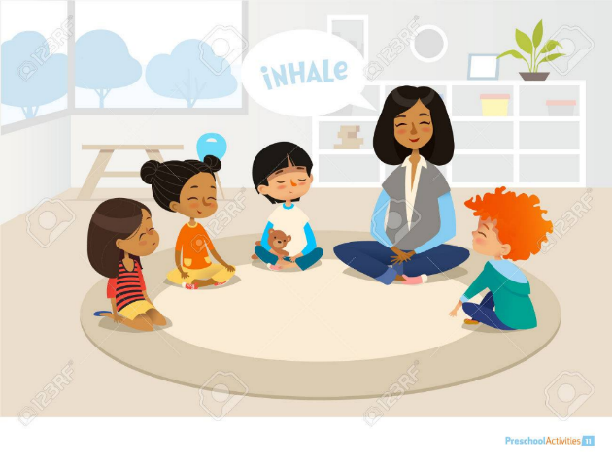

During this special time a small group will be gathered together to nurture and develop their emotional wellbeing, building their confidence and those secure attachments with familiar adults and their peers around them.

1. Take the group to a quiet area where they/practitioner will not be distracted by other children
2. Introduce the group by either singing a hello song/will you be my friend or simply talking and asking the children about their name
3. Introduce the activity and give them time to explore before intervention
4. Mirror their actions and when appropriate incorporate new situations for the child review and reflect on their own wellbeing
5. Finish the activity with goodbye song or saying goodbye, affirming their contribution to the session
6. Follow their play and talk about our time together during the day and support and stretch their learning from the group sessional work.
7. Ensure name and date participation sheet is filled.

This format is a loose structure to help formulate the foundations and understanding of the children’s needs. Being creative and adaptable will encourage and extend the child’s possibilities and potential as we provide a safe and tranquil environment to promote their development and learning.

As specified every child learns in different ways and at different rates, throughout the year we aim to organically disperse the nurture group as the child’s confidence grows in which their wellbeing can be fully supported within their own key groups, fun time building those attachments and friendships with peers and familiar adults.

Nurturing group time: