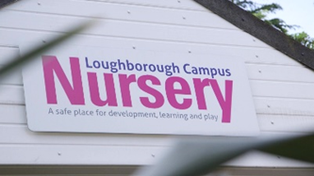

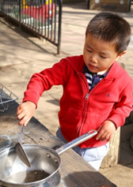

Tōku toa, he toa rangatira.
Identity, language and culture
Te Whariki

Here at Loughborough campus nursery, we give children opportunities to develop knowledge and understanding of not only their own cultural heritages, but also of their peers around them. Being located on a university campus with prestigious acclamation, the setting has an increasing number of children that reflects diversity and different beliefs every day. We use this opportunity to integrate and give children the opportunity to negotiate their learning through their own beliefs whilst being an active learner when in play. Cultural traditions and differences are vital in shaping the child’s own ideas that which is reflected in teaching and learning across all educational platforms. Children have come to be viewed as co-constructors of their own lives and cultures, through observing and participating actively in the community and society in which they live (Rogoff and Wertsch, 1984; Rogoff, 2003; Mayall, 2002; Corsaro, 2005; Tobin et al., 1991; Tobin, 2007).

Whatever corner of the world you’re from, our nursery is an invitation to explore the great diversity of language, and the experience the gift that it gives: HOPE, INSPIRATION, and a PROMISE for the FUTURE.

The childhood historian Dardess (1991) traces the history of childhood in pre-modern China and highlights the central role of Confucianism, a system of thought and behaviour, in shaping pedagogy and children’s learning in Chinese societies. As a setting we have our own beliefs and values that demonstrates how integral it is to be proactive and respectful of culture. Childhood and their identity are intertwined as learning takes place in social and communal contexts, alongside traditions, and everyday norms of their home and residency. Loughborough campus nursery endeavours to continually represent children’s identity from home life, encouraging all to see through a different perspective and different approach in learning collectively. This is represented in our environment, parent partnership and communal learning, e.g. our intergenerational project, happy to be me project and sibling play. Vygotsky’s work that highlights the nature of learning and the gradual internalisation of identity, is supported by our practice, we scaffold the children in their zone of proximal learning and provide opportunities they may not have experienced, as some children arrive at an early years setting with different roots and foundations for others.

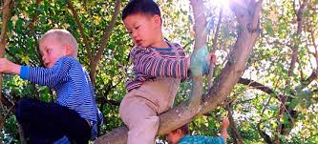

How do we demonstrate our cultural capital?

All children have cultural capital transmitted from their families and cultural context and that, no one form of cultural capital is more valuable than any other. Our setting ensures that all children entering the setting are given equal opportunities to succeed and provide a vast range of opportunities to extend their understanding and knowledge of their own culture and the people around them.
We demonstrate our cultural diversity daily, if not hourly – whether that’s asking the children to wash their hands before snack time to learning how to use chopsticks instead of a knife and fork, to reading their favourite book that interests them or role playing community figures such as the police. We love to learn about new customs and diverse experiences from all over the world, especially those relating to the cohort of children and will ask parents, guardians and friends to share those experiences with the children, with the importance being how this will benefit each child’s development. As simple as singing our “hello song” in a new language, this captures and connects the children with one another. Some example of what we do weekly are:
- Key group time, focused teaching and learning
- Society visits: art society, storytelling society, Hindu society, engineering society
- Culture in the community visits every Wednesday and Friday
- Parent partnership visits: musical performances, food tasting, craft making
- Trips out: Loughborough fair, library, pumping station
- Festivals and traditions
The investigators team have worked with the action students and volunteers over the past few years, establishing a fantastic society, culture in the community. This runs every Wednesday and Friday, time where the children can learn and extend their previous knowledge and understanding on diverse culture and integrate in their play.

